# Practice PL/SQL Variable Visibility

Example 1

In this example local and global variables are declared. You can see that inner block can use local as well as global variables. In outer block only global variable can be accessed.

Run this example on <https://onecompiler.com/postgresql>

DO $$

DECLARE

gl_name varchar(40) := 'Global Variable'; -- Global variable

BEGIN

RAISE NOTICE '%', gl_name;

-- Inner block

DECLARE

lc_name varchar(20) := 'Local Variable'; -- Local variable

BEGIN

RAISE NOTICE '%', lc_name;

RAISE NOTICE '%', gl_name;

-- Update global variable within the inner block

gl_name := 'Updated in INNER BLOCK';

END;

-- Output the global variable after inner block

RAISE NOTICE '%', gl_name;

END $$;

Output:

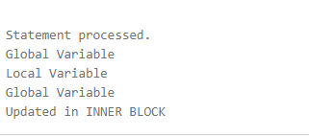

### Example 2

Explain why do we get an error in this example:

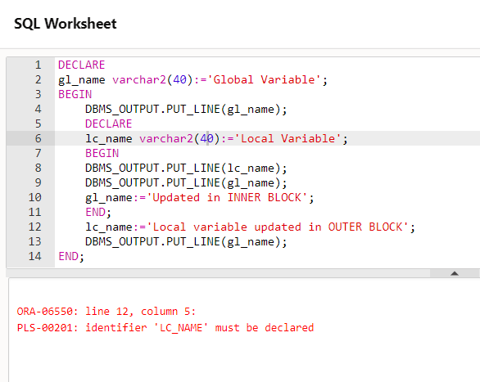

### Example 3

What is the output of this code, explain why we get this output?

DO $$

DECLARE

samename int := 100;

samenameG ALIAS FOR samename;

BEGIN

RAISE NOTICE '%', samename;

-- Inner Block

DECLARE

samename int := 200;

BEGIN

RAISE NOTICE '%', samename;

-- Accessing the outer block variable by referencing the outer block name explicitly is not directly supported in PL/pgSQL.

-- Instead, you can declare an alias for the outer block variable or use a different approach to avoid naming conflicts.

samenameG := 300;

RAISE NOTICE 'Local variable updated in inner block: %', samename;

RAISE NOTICE 'Global variable updated in inner block: %', samenameG;

END;

RAISE NOTICE 'Global variable after exiting inner block: %', samename;

samename := 500;

RAISE NOTICE '%', samename;

END $$;

### Example 4

What is the output of the following code:

DO $$

DECLARE

same VARCHAR(20) := 'same name';

BEGIN

RAISE NOTICE '%', same;

-- First inner block

DECLARE

samepeer VARCHAR(20) := 'same peer 1';

BEGIN

RAISE NOTICE '%', samepeer;

END;

-- Second inner block

DECLARE

samepeer VARCHAR(20) := 'same peer 2';

BEGIN

RAISE NOTICE '%', samepeer;

END;

-- Third inner block

DECLARE

samepeer VARCHAR(20) := 'same peer 3';

BEGIN

RAISE NOTICE '%', samepeer;

END;

END $$;